# What is Docker?

## Context

This research question is based on understanding what Docker is. Understanding and answering this question will help us to create a mineable viable product that uses continuous development and continuous integration. We will be answering this question with the help of the dot framework’s method and strategies shown below.

|  |  |  |  |
| --- | --- | --- | --- |
| **Method** | **Strategy** | **approach** | **expectation** |
| **Library** | Literature study | Finding general information online with relevant keywords to the question. | Information to answer the research question which also gives understanding to the topic. |
| **Field** | Problem Analysis | Making sure the problem is clear to what I would like to find out from answering this research question. | By making sure the question is clear to what problem I want to solve, I can make sure that I don’t lose track in the research I am doing. |

## Action / Summary

I have followed quite a of beginner tutorials from articles and YouTube where some worked best for me to understanding the general concept of docker and how to use it where others were to no help. Further, I received also available documents from my technical teacher Jacco where I could practice using docker. In this section I will touch down on a few tutorials I have followed to what I learned with a short reflection on each action I took. I also give next steps I will take on what I wish to improve on and how I will do so.

### Docker for Beginners: From Docker Desktop to Deployment

Site: [Docker for Beginners: From Docker Desktop to Deployment](https://www.youtube.com/watch?v=i7ABlHngi1Q&t=858s)

**Context / Reflection**

This video gave me an understanding into Docker (docker image autonomy and containers), learned docker definitions such as commands used and dockerized a react app and a WordPress application with a maria database.

This video has thought me about docker and gave me an understanding to how to dockerize an application. This video has been a great start for me to learn about docker and how to dockerize an app but I also learned from this tutorial is to try to learn how to dockerize other apps by watching videos or trying other methods and to learn more about the anatomy of a docker file.

Proof:

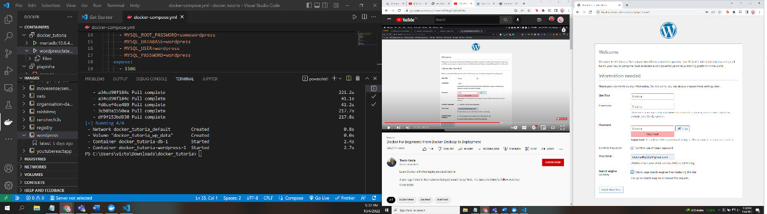



### Docker Tutorial for Beginners (YouTube video)

Site: [Docker Tutorial for Beginners](https://www.youtube.com/watch?v=pTFZFxd4hOI)

**Context / Reflection**

Regardless of this YouTube video being mostly focused Linux with docker, I can say that I did find this video helpful. Besides Linux with docker the video touches down on what docker is, comparison of virtual machines to containers, docker architecture and lastly actually dockerizing a react app. The video was clear and also provided decent visual aids that helped made docker for myself understandable.

I am not a professional, but I do have more of a better understanding of using docker and feel a bit more comfortable with the software.

**Next step**

My next step is to see how to dockerize an entire application (front, backend and database) where this video was only focused on dockerizing the frontend. By understanding how to dockerize an entire application, I can have an idea what I will need before developing the prototype for this research

### Docker Crash Course (YouTube video)

Site: [Docker Crash Course](https://www.youtube.com/watch?v=Wh4BcFFr6Fc&list=PL4cUxeGkcC9hxjeEtdHFNYMtCpjNBm3h7&index=11)

**Context / Reflection**

This course gives understanding and hands on work to understanding docker by describing images, containers, parent images, Docker file, starting & stopping containers managing images and containers, volumes, docker compose and lastly dockerizing a react app.

this is handy for more detail explanation and hands on action. In this tutorial, I dockerized another frontend react app but I learned much more concepts regarding docker such as managing images and volumes and docker compose which I find useful for continuous development.

**Next steps**

From this tutorial, I have changed my goal from learning to dockerize an entire application learning how to dockerize a microservice due to the prototype that I will be building is a microservice and not a monolith. With that being said, I find that it will be more efficient for myself to start learning dockerizing a microservice.

### Jacco learning material (ZIP file)

### Dockerize Microservice (Article)

Site: <https://medium.com/@madhukaudantha/dockerize-microservice-3d7562ffcda3>

## Literature Study (Library)

## Problem Analysis (Field)

## Sources

* JACCO:
  + <https://docker-curriculum.com/#static-sites>
  + <https://docker-curriculum.com/#playing-with-busybox>

# What is Unit Testing?

## Context

This research question is based on understanding what Unit Testing is. Understanding and answering this question will help us to create a mineable viable product that uses continuous development and continuous integration. We will be answering this question with the help of the dot framework’s method and strategies shown below.

|  |  |  |  |
| --- | --- | --- | --- |
| **Method** | **Strategy** | **approach** | **expectation** |
| **Library** | Literature study | Finding general information online with relevant keywords to the question. | Information to answer the research question which also gives understanding to the topic. |
| **Field** | Problem Analysis | Making sure the problem is clear to what I would like to find out from answering this research question. | By making sure the question is clear to what problem I want to solve, I can make sure that I don’t lose track in the research I am doing. |

## Action / Summary

To understanding how to integrate unit testing in code, I first did research into the topic to get a general understanding and look for some sources that could help me.

Before using these sources, I asked my fellow group mates if the sources were a great start and covering the knowledge I should know. As feedback I was informed that following one of the sources is enough to have a general understanding of unit testing where I can use this knowledge to create tests for example for functionalities of a calculator.

The following section touches down on the source I used for understanding and implementing unit testing in code and how it benefitted me.

### C# Unit Tests Using NUnit (.NET) (Beginner) (Youtube)

Site: [C# Unit Tests Using NUnit (.NET) (Beginner)](https://www.youtube.com/watch?v=uvqAGchg8bc&t=3s)

**Contexts**

This course I have learned how to create unit test with the concept (Arrange, Act, Assert) with very basic functions. It gave me the core concept on how to think and program regarding unit testing with using functionalities of a bank application and creating unit tests on these functionalities.

From the knowledge I acquired, I created unit tests for functions based on a calculator functions to apply what I have learned from this tutorial.

**Next step**

Create unit tests for the prototype I will be building based on the knowledge that have been acquired.

# What is System Testing?

## Context

This research question is based on understanding what System Testing is. Understanding and answering this question will help us to create a mineable viable product that uses continuous development and continuous integration. We will be answering this question with the help of the dot framework’s method and strategies shown below.

|  |  |  |  |
| --- | --- | --- | --- |
| **Method** | **Strategy** | **approach** | **expectation** |
| **Library** | Literature study | Finding general information online with relevant keywords to the question. | Information to answer the research question which also gives understanding to the topic. |
| **Field** | Problem Analysis | Making sure the problem is clear to what I would like to find out from answering this research question. | By making sure the question is clear to what problem I want to solve, I can make sure that I don’t lose track in the research I am doing. |

## Action / Summary

System Testing is…

(Still have to be done)

# What is End-to-End Testing?

## Context

This research question is based on understanding what System Testing is. Understanding and answering this question will help us to create a mineable viable product that uses continuous development and continuous integration. We will be answering this question with the help of the dot framework’s method and strategies shown below.

|  |  |  |  |
| --- | --- | --- | --- |
| **Method** | **Strategy** | **approach** | **expectation** |
| **Library** | Literature study | Finding general information online with relevant keywords to the question. | Information to answer the research question which also gives understanding to the topic. |
| **Field** | Problem Analysis | Making sure the problem is clear to what I would like to find out from answering this research question. | By making sure the question is clear to what problem I want to solve, I can make sure that I don’t lose track in the research I am doing. |

## Action / Summary

(Still have to be done)